Project –MINT Model Catalog Explorer

Introduction

This document outlines the mockup for the system for presenting models and their associated data in MINT in an amenable way to users. The system will have a search tool for exploring models available, pages presenting metadata of the models, configuration details and variables.

Mockup

1. Users enter the system via the search tool for exploring the model catalog. The page displays a sample of models available.

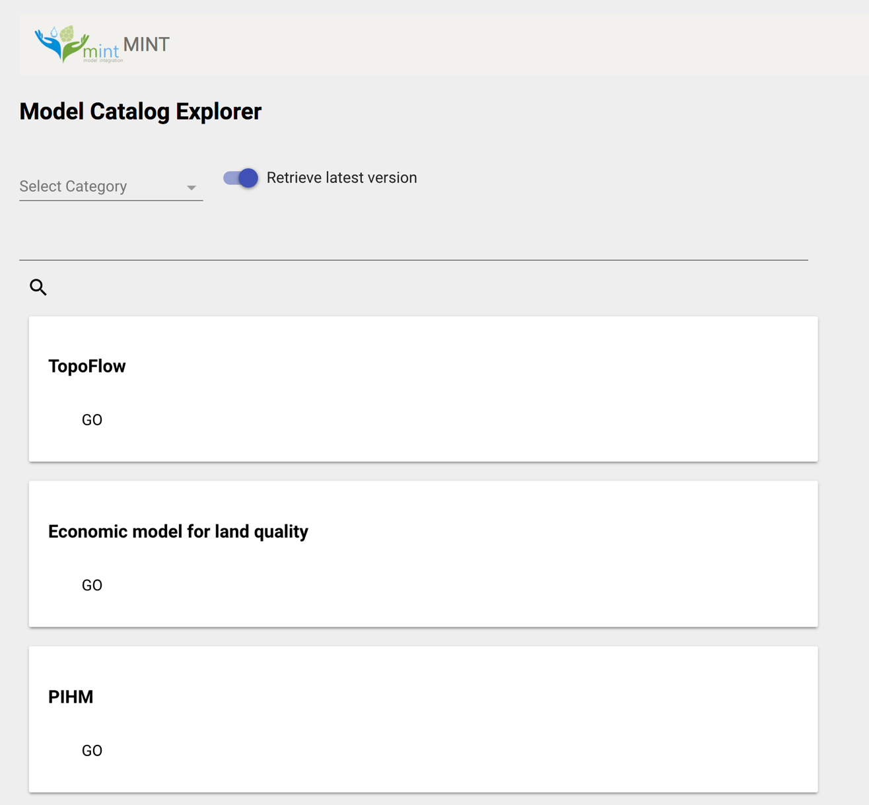

Fig. 1 – Search Page

1. Users enter descriptive words in the search bar and click on the search icon. Aditionally, users have the option to refine the search by selecting the category to which models belong (such as Economics or Agronomy), and whether to retrieve only the latest version or not. If there are matches, the system retrieves one or more results matching the search parameters. Else, no results are returned.

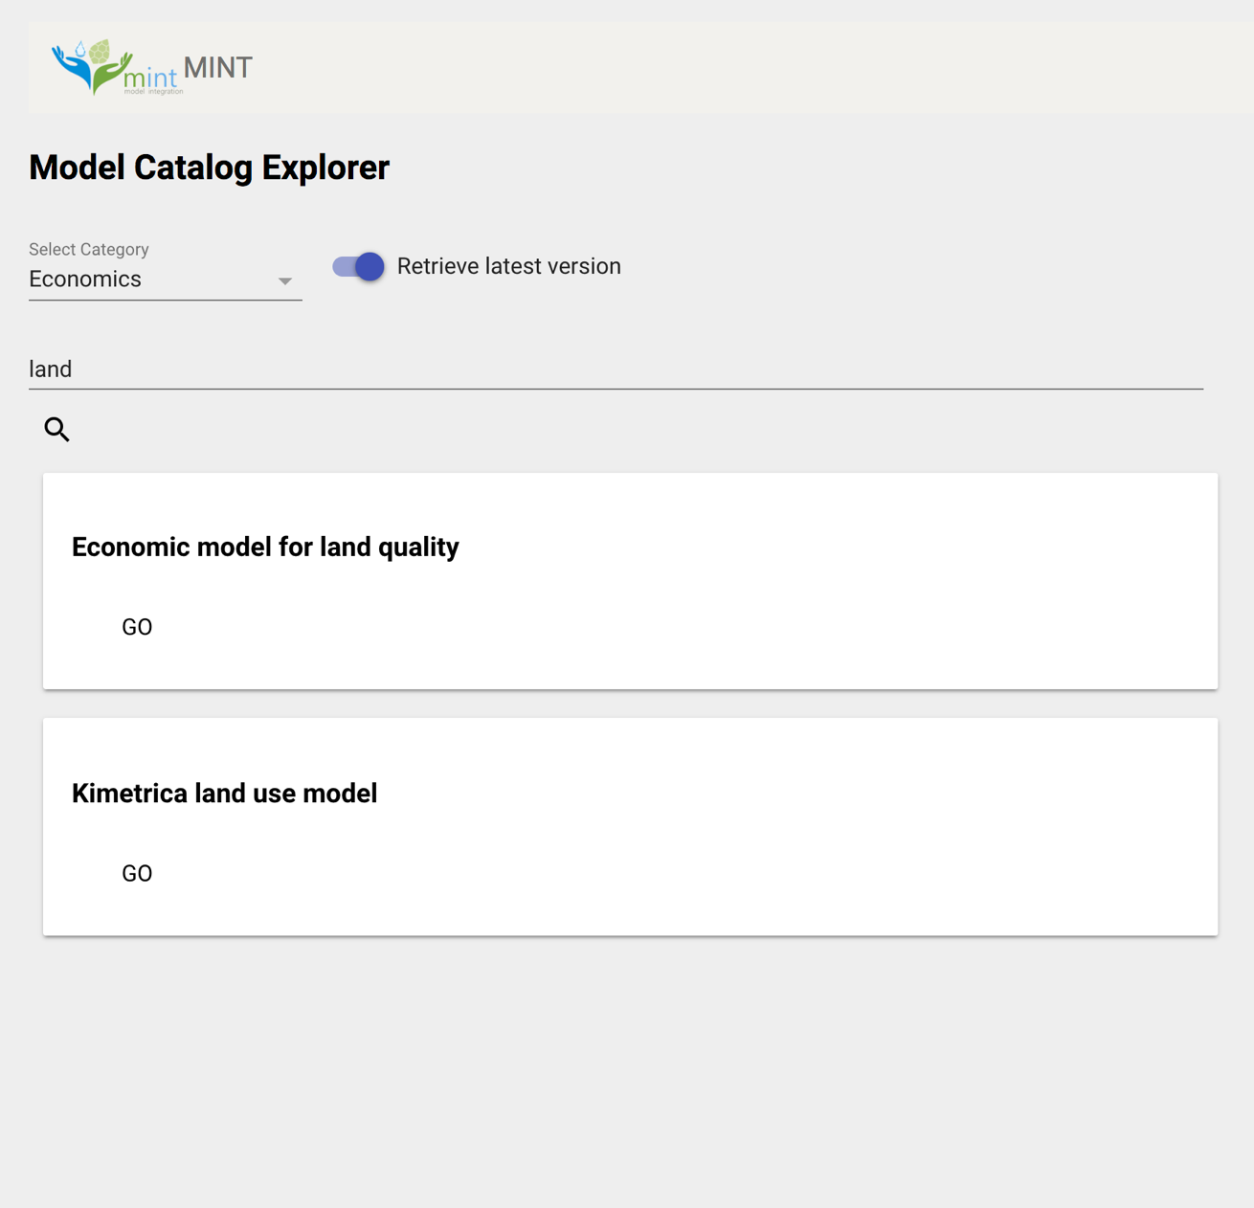

Fig. 2 – Returning results

1. Clicking ‘GO’ on a particular result takes users to the page for that result. This page contains metadata about the particular model. Here also, users can change the version to get different instances of the same model.

Apart from the metadata, the available configurations of the model are displayed in a tabular format.

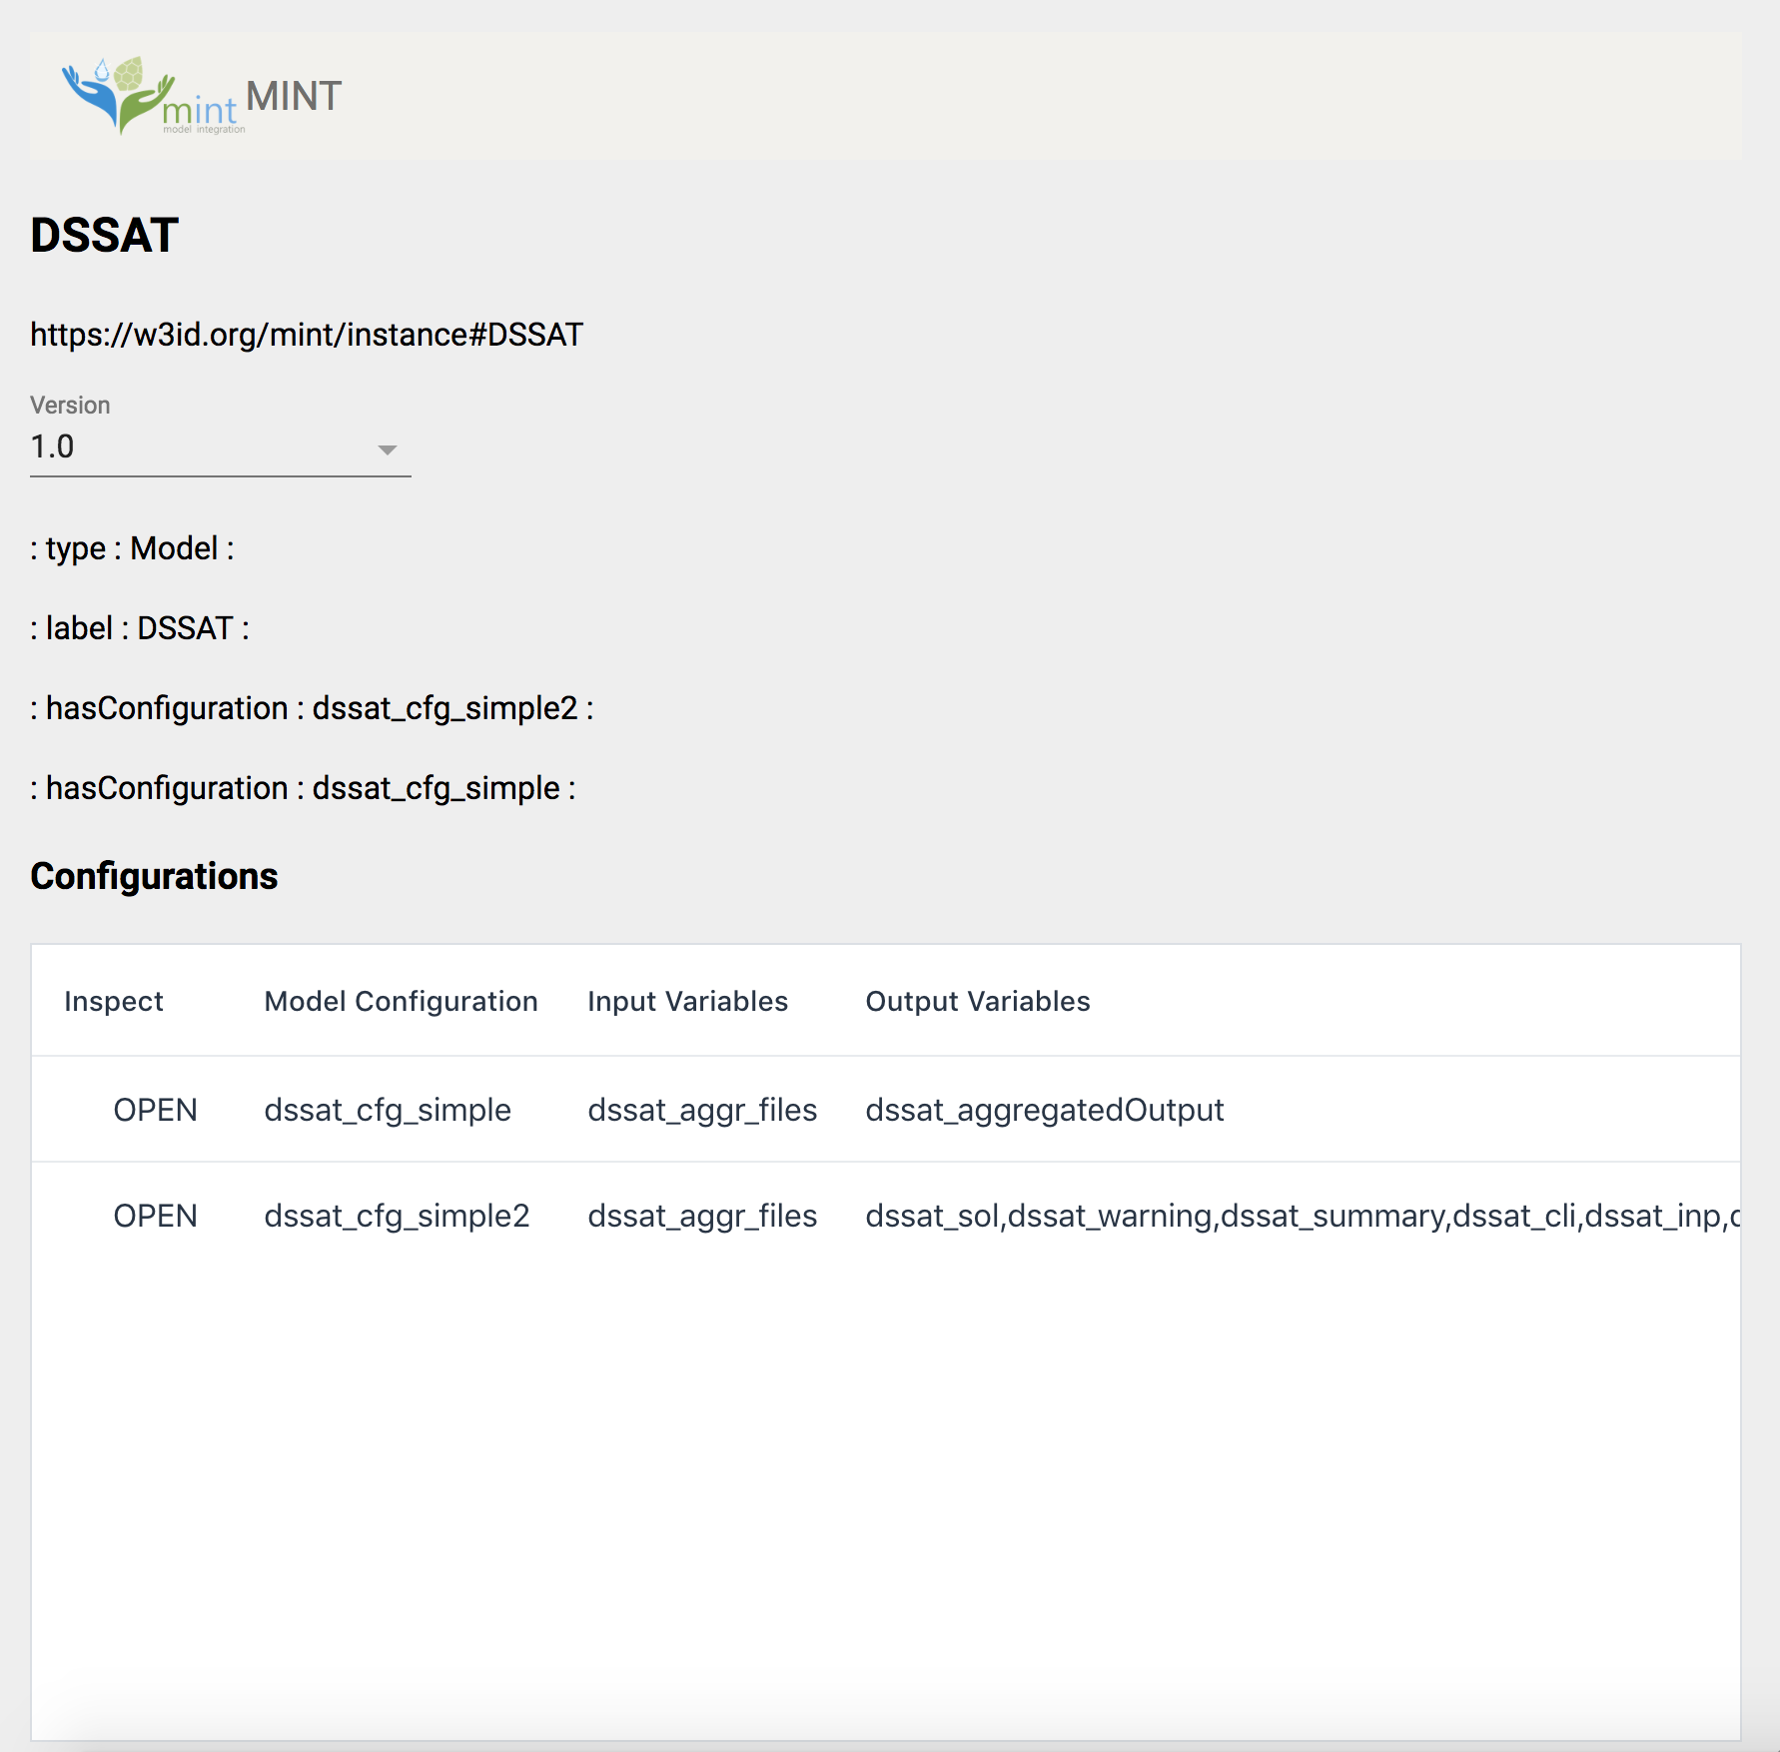

Fig. 3 – Model Description

1. Clicking on any of these configurations takes users to a page that describes the configuration in detail. The salient features are the input and output variables, datasets.
2. Clicking on any of the variables opens up a page that presents all the metadata about the variables.